Module Three:
Leading and Managing the Work of the Governing Body

Key themes
This module focuses on the Chair’s leadership role in enabling the Governing Body to organise itself and its work efficiently and effectively.

This module contains activities which explore:
- Pre-session task – collecting information on committee structure
- The Chair’s planning role – overview
- Membership of the Governing Body
- Structuring the Governing Body
- Planning a strategic framework
- Working with the Clerk to plan meetings
- Active listening
- Managing conflict
- Managing meetings
- How the Chair can share out work to good effect
- How the Chair ensures effective minutes are taken

Adapting the module
All activities and their related handouts and overheads are numbered but you can tailor this module to the needs of the participants and to the amount of time available by:
- Omitting some activities altogether
- Changing the order of the activities
- Shortening activities by transferring information to handouts
- Supplementing activities with your own material

Timings, appropriate for groups of 10 – 12, have been included to give an indication of the approximate length of each activity

Whole governing body development
Some of the activities in this module are suitable for adapting for whole governing body development

Learning Record
You may want to re-introduce the Learning Record before your first activity, in which case you may need spare copies.
Module Three: Overview

Activity | Topics | Approx  Time
3.1 | The Chair’s Role in planning the work of the Governing Body  An introduction to the module outlining the Chair’s role in planning the work of the Governing Body | 20  mins
3.2 | How many members?  A debate about the pros and cons of varying sizes of Governing Bodies | 30  mins
3.3 | How many committees?  An exploration of options for the organisation of the Governing Body and their impact on efficiency and effectiveness | 50  mins
3.4 | Planning a strategic framework  Participants consider when, during the annual cycle, to tackle a number of priorities and regular agenda items | 40  mins
3.5 | Working with the Clerk  The role of the Clerk and how the Clerk and the Chair work together | 50  mins
3.6 | Active listening  A paired activity exploring communication skills | 30  mins
3.7 | Dealing with challenging situations  An exploration of the skills required to manage conflict and support other governors | 60  mins
3.8 | Managing an effective meeting  An activity based on a self-evaluation of individual skills in managing meetings | 20  mins
3.9 | Chairing meetings  An opportunity to practise and reflect on chairing skills and the management of decision making | 40  mins
3.10 | Does it have to be the Chair?  An enquiry into strategies for ensuring that the Chair does not take on too much | 30  mins
3.11 | Is this a good minute?  An activity outlining the importance of accurate minutes and the Chair’s role in ensuring that the work of the Governing Body is adequately reported | 30  mins
3.12 | Plenary session  Summarising learning and preparing for the next session | 15  mins

Skills addressed in this module

Skills and Attributes  Activity | Team building skills | Organisational skills | Communication skills | Strategic skills | Analytical skills
3.1
3.2 | √ | √ | √
3.3 |  | √ | √ | √ | √
3.4 |  | √ | √ | √ | √
3.5 | √ | √ | √
3.6 |  |  | √
3.7 |  |  | √
3.8 | √ | √ | √
3.9 | √ | √ | √
3.10 | √ | √ | √
3.11 | √ | √ | √ |  | √
3.12

Activity 3.1: The Chair’s role in planning the work of the Governing Body

Aims

- To provide an overview of the Chair’s role in planning the work of the Governing Body
- To consider the planning role in the context of the three key roles of the Governing Body
- To consider the impact of the Chair’s effective planning on the Governing Body’s contribution to school improvement

Overall length

- 20 minutes

Resources

- Activity 3.1: OHTs 1-6
- Flip chart and pens

Key notes for Facilitators

- This is a short introductory activity to introduce participants to each other, to recap on the previous session and to introduce the module

Task 1: Welcome and introductions

- If the group has new members or you are new to the group, you may wish to start the session with the usual introductions, housekeeping and ground rules
- Encourage reflection by putting a question on the flip chart such as “What were your key learning points from the last session” or “Have you changed/or planned to change anything in the way you work since the last session?” and ask participants to reflect on this as they come in
- Recap on the previous session by asking for responses to your questions
- Suggest that the participants use their Learning Record to record key learning points during the course of this session
- The remainder of the activity is to introduce the participants to the module and to make some key points about the role of the Chair in planning the work of the Governing Body

Facilitator introduction (5 minutes)

Task 2: Introducing the module and the role of the Chair

Use the Activity 3.1: OHTs 1-3 to introduce the module. It might be helpful to remind participants of what has already been covered and the general contents of Modules 4 and 5

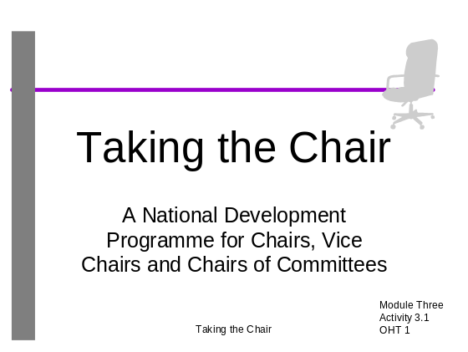

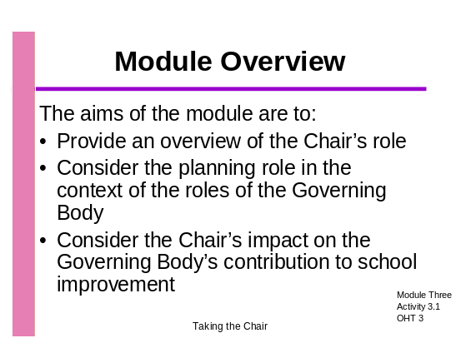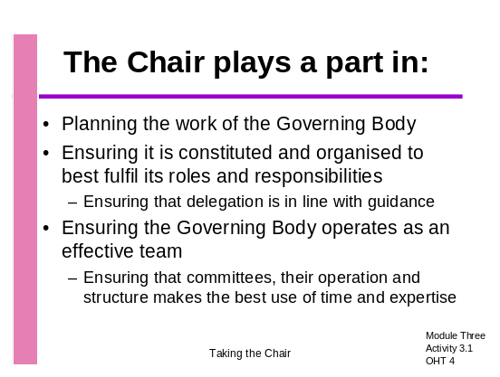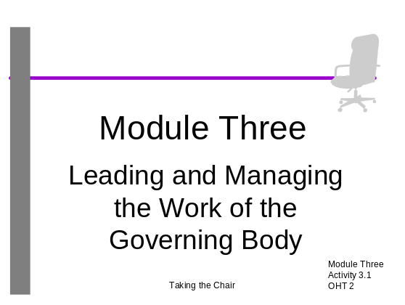
Use Activity 3.1: OHT 4 to introduce an overview of the role of the Chair

- You may be focusing on some of these roles in the activities you have chosen and now might be the appropriate time to run through your programme and highlight the topics you will be including

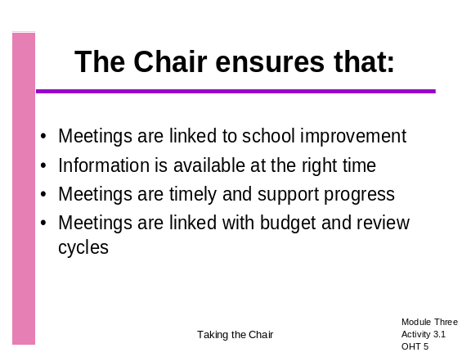Use Activity 3.1: OHT 5 to outline the Chair’s role in leading and managing meeting schedules – the key points to make are:

- The schedule of Governing Body meetings should be linked to the school improvement planning cycle
- Information for discussion and decision making should be available before meetings and in line with the improvement cycle
- The Chair can support the Headteacher by ensuring that the Governing Body considers plans and policies in time for them to be agreed and does not hold up implementation
- Meetings also need to be scheduled around the budget planning cycle and cycles for the review of policies, monitoring and progress
- The idea of a strategic framework which ensures that this happens is explored in later activities

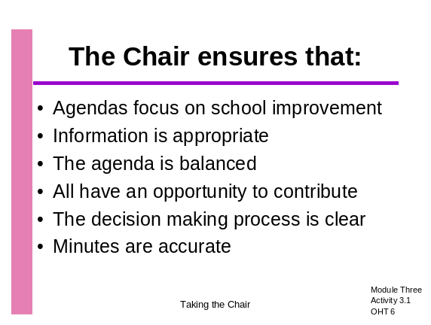Use Activity 3.1: OHT 6 to make the following points about the management of meetings themselves:

When planning, organising and chairing meetings, the chair should ensure that:

- Agenda items are related to strategic school improvement
- Information is presented in advance and in a form that all can understand
- There is enough time to discuss important items and this is reflected in the balance of the agenda
- Everyone has an opportunity to contribute
- The decision making process is clear to all
- Accurate minutes are produced and circulated

Facilitator presentation (15 minutes)

Activity 3.2: How many members?

Aims

- To consider the impact of legislation on the size and composition of the Governing Body
- To consider the advice Chairs might give to their Governing Bodies on membership
- To provide practice in presenting an argument

Overall length

- 30 minutes

Resources

- Activity 3.2: OHT 1
- Guide to the Law, Chapter 2: How Governing Bodies are made up in community, foundation, VA and VC schools
- Flip chart and pens

Key notes for Facilitators

- Regulations taking effect from 1st September 2003, contained in the Statutory Guidance on School Governance (Constitution)(England) Regulations 2003, require all Governing Bodies to review their membership by September 2006. This change in legislation gives Governing Bodies much more freedom to choose the size of the body rather than it being determined by the number of pupils on roll. The total number of governors can vary between 9 and 20.
- Although all Governing Bodies must make a decision by September 2006, this is not a once and for all decision and changes can be made if the needs of the school change
- Chairs need to ensure that discussions take place to enable the Governing Body to plan for change
- There is a similar activity in the National Development Programme for Clerks to Governing Bodies, so if the Clerk has been on this training, he/she would be a good source of advice on this topic
- Issues influencing a decision on the number of members of a Governing Body include:
  - A small Governing Body will result in only two staff members. One place is reserved for the Headteacher, the second place must go to a teacher, unless no-one stands, leaving no place for a member of the support staff
  - A small Governing Body may have difficulty in finding sufficient Governors to sit on appeals committees (for example on a staff dismissal case) if some are barred from doing so (the head) and some may not wish to do so (other staff) and others are debarred because they have prior knowledge.
  - A small Governing Body with a number of committees may put a burden on individuals who have to attend meetings of several committees
  - Large Governing Bodies may be more difficult to manage and individual contributions may be reduced
- Governing Bodies may also consider Federation (2 or more schools under one Governing Body) or Collaboration (2 or more schools pooling resources – e.g. making a joint appointment of a specialist teacher or a bursar or joint committees comprising members of the different Governing Bodies.

Task: How many members do we want?

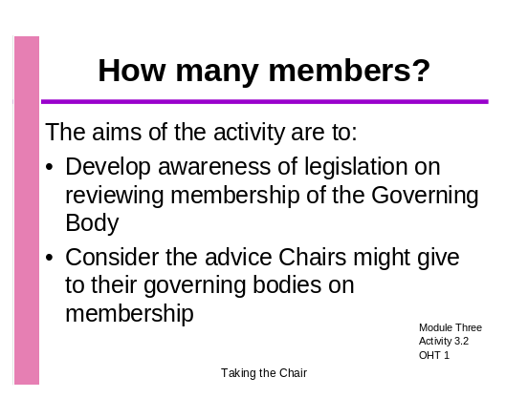Use Activity 3.2: OHT 1 to introduce the activity

- Remind participants of the legislation regarding a review of membership and that there are a number of pros and cons for large and small governing bodies. Ask for just one or two very brief suggestions of what the issues might be to get people thinking in the right area
- Divide participants into two groups
- Ask Group A to speak in favour of small Governing Bodies
- Ask Group B to speak in favour of large Governing Bodies
- Give each group about 12 minutes to prepare their case and 5 minutes to present their case to the other group
- Ask them to think about how they will present their case – will they have only one spokesperson from the group, or will they all take a role?
- Put the essential instructions and timings on a flip chart so that the groups can refer back to them as they work

Facilitator introduction and preparation of presentation (15 minutes)
Group presentation (5 minutes each) (10 minutes)

- When both groups have presented their cases take a vote.
- Ask participants what steps have been taken to start this debate on their Governing Body and whether they think their present membership works for them
- Remind them of sources of information (Guide to the Law, DfES Governor website, the LEA and the Clerk)

Plenary (5 minutes)

Activity 3.3: How many committees?

Aims

- To consider the effectiveness of a number of organisational structures and learn from the practice of others
- To consider how the context of the school influences the committee structure
- To consider how to make best use of committees and ensure effective reporting back systems

Overall length

- 50 minutes

Resources

- Activity 3.3: OHT 1
- Activity 3.3: Handouts 1 and 2 (sent out in advance of the session)
- Activity 3.3: Handouts 3 and 4
- Examples of committee structures
- Examples of terms of reference of committees
- Guide to the Law
- Flip chart, Blu-Tack and pens

Key notes for Facilitators

- As many of your participants will be relatively new Chairs, or may not yet be Chair, this activity provides them with the opportunity to review and consider the pros and cons of a variety of committee structures
- The activity will also stimulate more experienced Chairs to think afresh about the structure of their Governing Body
- Some of the issues to consider when deciding the number of committees are:
  - What decisions can be delegated to a committee, individual or the Headteacher - see Statutory Guidance on the School Governance (Procedures)(England) Regulations 2003. Ref DfES/0430/2003 in the latest version of the Guide to the Law
  - When delegating to the Headteacher, does the Headteacher have the necessary experience, school leadership team and good management systems in place to effectively undertake the task?
  - What is the overall size of the Governing Body and are there enough members to serve on committees without overburdening individuals?
  - Are there enough committees to get through more than the average amount of work? (For example if we are a school in special measures)
  - How can duplication of effort be avoided?
  - Is there enough experience and expertise to spread among the committees so that decision making can be safely delegated to them?
  - Are there enough people to chair and clerk committees?
  - Do a small number of committees put too much influence in the hands of a few?
  - Do committees share the review of policies?
  - How efficiently and effectively are reports from committees dealt with – remembering that the Governing Body retains legal responsibility for decisions?
  - What support might committee Chairs need?
  - Would the opportunity to chair a committee help develop future Chairs of the Governing Body?
- There is a similar activity in the course reader for the National Development Programme for Clerks to Governing Bodies, so if the Clerk has been on this training, he/she would be a good source of advice on this topic
- You might also remind participants of the interactive decision planner on Governornet
- This activity focuses on how decisions are made about the number and type of committees and methods for reporting back – the timing of committee and Governing Body meetings and the agenda items for them are dealt with in Activity 3.4. The object is not to recommend a particular structure. One size will not fit all.

Task 1: Identifying the issues

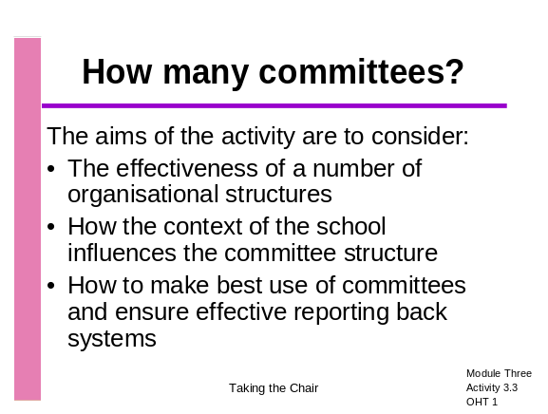Introduce the activity using Activity 3.3: OHT 1

- Lead a brainstorm on the issues to consider when deciding the committee structure (see key notes for facilitators above) and flip chart the issues – but not the solutions or recommendations. You might ask, “What are the issues we need to think about when deciding the committee structure of the Governing Body?” The issues have been listed on Activity 3.3: Handout 4 and you may wish to hand this out at the end of your brainstorm session

Flip charting issues (10 minutes)

Task 2: Suggesting solutions

- Divide the participants into groups of 3 or 4 according to the current size of their Governing Body or other criteria that you think will ensure that participants from schools in fairly similar circumstances work together
- Ensure that participants have completed the pre-session task or give them examples of Governing Body structures
- Give out Activity 3.3: Handout 3 and ensure the group understands the task before giving them 15 minutes to complete it
- Give each group a flip chart sheet and pens

Group work (20 minutes)

- Lead a question and answer session by inviting each group in turn to present their 5 recommendations and 3 Hot Tips in 5 minutes and to answer questions from the other groups
Reporting back (20 minutes)

Structuring the Governing Body

Pre-session task

In preparation for Module Three, please try and find the time to make the following notes on the recording sheet provided.

- Make a list of your Governing Body committees

- For each committee make a brief summary of its remit

- Make notes in answer to the questions below:

- When was the composition of the Governing Body last reviewed?

How did you decide on the number and remit of committees?

What is the value of these committees to the Governing Body?

- When do committees meet in relation to the main Governing Body and does it enable efficient and effective reporting back to the Governing Body?

Any other comments or queries about committee structures?

- How many members on your Governing Body?

Structuring the Governing Body: Recording sheet
Please make an extra copy of this sheet if you have more committees than will fit here

Our Committees | Their Remit

How many committees?

Task sheet

In your group discuss:

- How efficiently and effectively your governing bodies are organised (using your pre-session notes)

- Agree 5 recommendations for the organisation of Governing Body committees and put them on a flip chart

- Agree 3 ‘Hot Tips’ for ensuring the committees effectively report back to the Governing Body

You will have 5 minutes to make your recommendations and give your tips.

How will you organise your feedback? For example, will all of you take a turn to speak or will you select one spokesperson?

Some Of The Issues To Consider When
Deciding The Number Of Committees

- What decisions can be delegated to a committee, individual or the Headteacher - see Statutory Guidance on the School Governance (Procedures)(England) Regulations 2003. Ref DfES/0430/2003 or the latest version of Guide to the Law

- When delegating to the Headteacher, does the Headteacher have the necessary experience, school leadership team and good management systems in place to effectively undertake the task?

- What is the overall size of the Governing Body and have we enough members to serve on committees without overburdening individuals?

- Do we have to get through more than the average amount of work? (For example if we are a school in special measures)

- How can we avoid duplication of effort and make the best use of people’s time?

- Do we have enough experience and expertise to spread among the committees so that we can safely delegate decision making to them?

- Do we have enough people to be the Chairs of committees and clerk them?

- Do a small number of committees put too much influence in the hands of a few?

- Do people feel more committed if they are involved in working on committees?

- Do our committees share the review of policies?

- How efficiently and effectively do we deal with reports from committees – remembering that the Governing Body retains legal responsibility for decisions?

- What support might committee Chairs need?

- Would the opportunity to chair a committee help develop future Chairs of the Governing Body?

- Could we make more use of Working Groups to take on specific tasks?

Activity 3.4: Planning a strategic framework

Aims

- To develop confidence in constructing a strategic framework for the Governing Body to monitor and evaluate policy, practice and impact
- To consider the issues to be taken into account when scheduling the work of the Governing Body and its committees

Overall length

- 40 minutes

Resources

- Activity 3.4: OHTs 1 and 2
- Activity 3.4: Handouts 1-3

Key notes for Facilitators

- This activity encourages participants to consider how to plan the Governing Body’s annual workload
- The issues are taken from Ofsted forms S3 and S4 which many schools are maintaining on an ongoing basis
- The issues are a mixture of statutory requirements and questions about standards and quality
- Governing bodies, often represented by the Chair but also including other governors, will be expected to have the evidence to support their judgements on these issues when discussing them with inspectors
- The participants will need to consider what evidence the Governing Body will need in order to support their judgements on these issues, how it will be gathered, when and by whom
- Remind participants about the online year planner www.governornet.co.uk/calendar

Task1: Planning a strategic framework
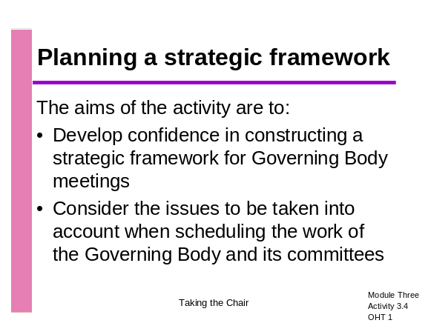
Introduce the activity using Activity 3.4: OHT 1

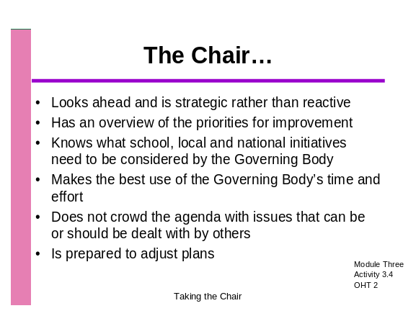Activity 3.4: OHT 2 outlines the key elements of the Chair’s role in enabling the Governing Body to plan its work

Facilitator introduction (5 minutes)

- Divide groups into trios – this activity works best if group members come from similar size schools so group primary with primary and secondary with secondary if possible. You may have enough participants to distinguish between small and large primaries. This is an opportunity to move groups around to give people a variety of others to work with
- Give out Activity 3.4: Handouts 1-3
- Suggest which issues each group might tackle so that they are all covered and each group does not try to do too many in the time available
- Check that everyone understands the task
- Circulate while the groups are working to ask and answer questions and challenge decisions
- If a group decides that its school will not have committees but always work through full Governing Body meetings, ask them to plot the relevant agenda items on the Annual Calendar of Work and to think about who will be invited to present information to the Governing Body
- Ask participants whether they ever set up Working Groups and what kinds of tasks do they ask them to carry out.
Group work (25 minutes)

- Hold a plenary discussion to probe what the groups have learned from this exercise:
- What issues did the activity throw up?
- What is their normal practice for planning the work of the Governing Body?
- Do they have an annual calendar of work and does it allow them to gather this sort of evidence in a regular and systematic way?
- Are they making the best use of committees?

Plenary discussion (10 minutes)

Planning a strategic framework: The Task

Background

You are the Governing Body of a school.
It is the start of the autumn term.

The items on Handout 2 are taken from Ofsted forms S3 and S4. The Governing Body is expected to be able to provide the answers to these questions and have the evidence to back its judgements.

Your task is to plan the work of the Governing Body and its committees so that these issues are monitored and evaluated.

With your group:

- Decide which committees the Governing Body of this school will have

- Which of the issues could be put on a committee agenda? Which committee?

- At which committee meeting should the issue be considered, bearing in mind when relevant information is likely to be available?

- At which meeting will the issue be brought to the Governing Body and who could be invited to present information?

Plotting agenda items on the Annual Calendar of Work

Plot appropriate agenda items on the year planner so that the issues below are considered by the appropriate committee and/or the Governing Body.

The Annual Calendar of Work already includes some items that must be covered in meetings. You may consider moving some of these items.

- Does the school meet the requirements of the general duty and the specific duties in the Race Relations (Amendment) Act 2000 and the Commission for Racial Equality (CRE) Code of Practice?

- Does the school have regard to the Special Educational Needs Code of Practice when meeting pupils' special educational needs and make its policy known to parents?

- Does the Governing Body have procedures for ensuring the school meets all relevant health and safety legislation?

- Do the school's procedures for child protection follow the requirements of the local area Child Protection Committee, and does the Governing Body ensure that these are followed?

- Does the Governing Body have a performance management policy and does it ensure that all teachers, including the Headteacher, are appraised in accordance with statutory requirements?

- How effective are teaching and learning?

- How well are pupils' attitudes, values and personal qualities developed?

- How well does the school work in partnership with parents, other schools and the community?

Autumn Term |  | Spring Term |  | Summer Term
Full Governing Body | Committees | Full Governing Body | Committees | Full Governing Body | Committees
Elect Chair and vice Chair (if this is what the GB has decided) | Elect Chair and Vice Chair | Agree budget | Review policies | Review Governing Body performance this year | Review staff pay
Agree delegation and terms of reference | Plan annual programme of work | Agree staffing structure |  | Report on operation of Performance Management Policy
Prepare and approve Annual Report to Parents
Plan annual programme of work | Arrange Headteacher’s performance management review
Review School Improvement Plan |  | Review School Improvement Plan |  | Review School Improvement Plan

Activity 3.5: Working with the Clerk

Aims
- To identify good practice in planning meetings
- To emphasise the role of the Clerk and build confidence in working with the Clerk
- To encourage ownership of the agenda by the Chair and the Governing Body

Overall length

- 50 minutes

Resources

- Activity 3.5: OHT 1
- Activity 3.5: Handouts 1-2
- Model Job Description: National Training Programme for Clerks to Governing Bodies, Course Reader, page 106: at least one copy per group
- Flip charts and pens

Key notes for Facilitators

- You could start this activity by outlining the clerking services in your area
- Many Chairs are unaware of what can be expected of a Clerk or the level of service for which they are paid
- The relationship with the Clerk will be an important one for a new Chair
- Chairs need to be aware of what level of support they can expect from the Clerk
- The Clerk serves the Governing Body and not the Headteacher
- The Chair is responsible for the agenda and the order of items on it
- The agenda items should reflect the Governing Body’s focus on school improvement and their three key roles: Strategic view, critical friend and ensuring accountability
- The Chair should know in advance what the Headteacher’s report contains and can ask the Headteacher for information which has not been included
- You might wish to have a discussion about ‘Any other business’. This can be used inappropriately, for example when Governors raise issues that take the Headteacher and other Governors by surprise or when issues are raised that need prior notice to allow for information to be gathered and reflection time. Some governing bodies do not have ‘AOB’ on the agenda at all, but practice varies.

Task 1: Working with the Clerk
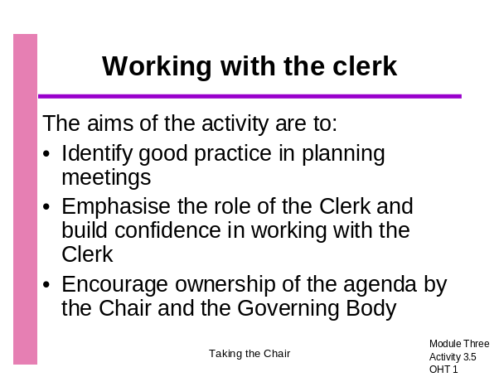
Use Activity 3.5: OHT 1 to introduce the activity

  - Group participants in trios
  - Give out Activity 3.5: Handout 1 Working with the Clerk
  - Ask trios to read through and discuss their experiences of working with the Clerk

Facilitator introduction and trio discussions (10 minutes)

- Now give out Activity 3.5: Handout 2, Planning Checklist, and ask participants to complete this in their trios
Trio work on checklist (10 minutes)

- Ask participants to feed back any key issues and any examples of good practice
- Note these on a flip chart and encourage participants to share ideas and good practice
- Make any key points that are not raised by participants

Plenary discussion (10 minutes)

Task 2: Other steps to take before meetings

- Give each group a flip chart sheet and pens
- Give the groups 10 minutes to list other steps the Chair might take before meetings to ensure that meetings are well managed (assume that all the actions highlighted in ‘Working with the Clerk’ have been carried out)

Group work (10 minutes)

- Display the flip charts, give participants the opportunity to look at lists
- Comment on any good practice noted and any items omitted
- Additional items might include:
  - Setting yearly timetable of meetings in advance
  - Agreeing the length and timing of meetings to suit most governors
  - Ensuring that the meeting room is suitable/comfortable and visual aids work
  - Deciding in advance whether refreshments are served and when
  - Avoiding tabling documents unless essential

Discussion of flip charts (10 minutes)

Working with the Clerk

Every Governing Body must appoint a Clerk
Clerks may:
- Be experienced or inexperienced
- Have completed the National Training Programme for Clerks of Governing Bodies
- Be a member of an LEA clerking service

The tasks that may be delegated to a Clerk vary according to:
- The level of pay and agreed level of service
- The agreed job description

The Governing Body makes decisions and takes responsibility – the Clerk supports them in doing so

How the Clerk supports the Chair
A good Clerk:
- Is knowledgeable and advises the Chair and the Governing Body
- Ensures that the Governing Body is acting within regulations
- Keeps the Chair and others up to date with initiatives and legislation
- May have experience of good practice in other contexts
- Gives the Chair confidence that the right things are being done in the right way

How the Chair can support the Clerk
The Chair can:
- Work closely with the Clerk to ensure the Governing Body is well informed
- Encourage the Clerk to attend LEA briefings and seek information from the DfES and LEA web sites
- Encourage the Clerk to undertake the National Training Programme
- Encourage the Clerk to maintain good record-keeping systems

What the Chair and the Clerk do together
- Ensure that all papers are prepared for meetings including committee meetings
- Ensure that all relevant papers are circulated seven days in advance of meetings

Working with the Headteacher and the Clerk, the Chair ensures:
- That all agenda items are clearly set out
- That items are set out in an order which will ensure that sufficient time will be allocated to discussing matters of high importance
- That there are no surprises in the Headteacher’s report
- Items focus on school improvement and the three key roles of the Governing Body: strategic view, critical friend and ensuring accountability

The Chair ensures that committee Chairs follow the same procedures

Working with the Clerk – Planning Checklist

Use the Clerk’s job description from the National Programme for Clerks of Governing Bodies to refresh your understanding of the role of the Clerk
Who should be consulted when drawing up the agenda?
How should the order of items on the agenda be decided?
When should the preparation and distribution take place?
What information is needed in advance and how are governors going to receive this?
What is the purpose of ‘Any Other Business’?
Tips for working successfully with the Clerk and the Headteacher that you want to take away from this session:

Activity 3.6: Active Listening

Aims

- To encourage participants to analyse their own listening skills
- To develop their understanding of communication skills

Overall Length

- 30 minutes

Resources

- Activity 3.6: OHT1
- Activity 3.6: Handouts 1 and 2
- Plain paper, pencils and clip boards

Key notes for Facilitators

- This is an active listening exercise designed to identify the positive and negative aspects of verbal communication skills
- Participants will work in pairs, sitting back to back and as far away from other pairs as space will allow
- You will need to copy the handouts on to plain white paper. Only one person in each pair should see the handout allocated to them. Participants can choose which of the designs on the handout they use in the exercise.
- If you would like to include this activity but need to reduce the time allowed, give a diagram to a volunteer and ask them to describe it to the whole group. Put the diagram on an OHT to show to the group at the end of the activity

Task 1: Active listening

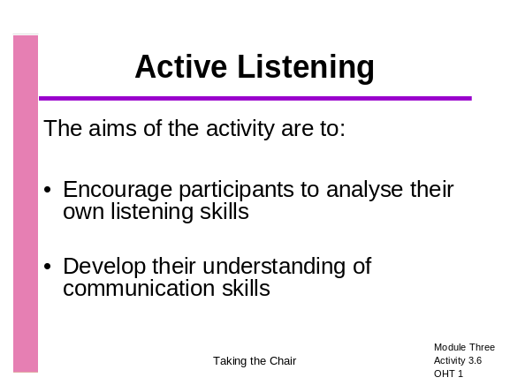Introduce the activity using Activity 3.6: OHT 1

- Give out Activity 3.6: Handout 1 to one participant and plain paper and pencil to the other
- The participant with the handout has to describe what they see in such a way that the person with the pencil and paper sitting back to back with them can draw the same diagram
- People drawing may ask questions for clarification and accuracy, but may not see the diagram.
- Listen to the pairs and note the kind of language they are using, what questions are being asked, what misunderstandings occur etc. Note how well participants listen to instructions and how clearly the instructions are given

Instructing and drawing (10 minutes)

- Stop the activity and discuss how easy or difficult the drawers found it to follow the instructions and why.
- Repeat the exercise with roles reversed, using Activity 3.6: Handout 2

Instructing and drawing (10 minutes)

- Lead a plenary discussion:
  - Did the process improve the second time around and if so, why?
  - Which communication skills were they using? – Responses might include paying attention, active listening, reflecting, summarising, managing silence, encouraging, echoing, checking, clarifying, expressing feelings, verifying conclusions, asking for examples, questioning etc.
  - Widen the discussion to include questioning techniques (did they ask the right questions?) and the importance of body language (and how this makes normal communication much easier) and the environment (noise, distraction etc).
  - What do they think is the connection between this activity and their roles as Chairs, Vice Chairs etc.?
  - Link the activity and learning points to the vital communication role of the Chair.
  - Can they think of situations which could have been improved by a more conscious use of communication skills?
  - Are there any communications skills which they know they could improve (you might want to admit to one yourself!)
  - Stress that verbal communication is a two way process involving both listening and talking. (Refer participants to the questioning skills outlined in Activity 1.5)

Plenary (10 minutes)

Activity 3.7: Dealing with challenging situations

Aims

- To identify ways to respond to conflict within the Governing Body

Overall length

- 60 minutes

Resources

- Activity 3.7: OHT 1
- Activity 3.7: Handouts 1-3
- The video from the Training Programme for New Governors: scenario Time and the Word.
- Video player and TV or digital projector

Key notes for Facilitators

- The video demonstrates very poor practice in the organisation of the finance committee’s meeting – Ashok, the new member of the committee is not given proper notification of the arrangements for the meeting; papers are tabled; the Headteacher and the Chair clearly make decisions outside the framework of the committee’s work; time is wasted.
- Whilst the process understandably aggrieved Ashok, it would have been better if he had challenged in a more constructive manner.
- When we are attacked our natural reaction is to defend
- In situations like this it is vital for the aggrieved person to feel heard. The maxim ‘seek first to understand then to be understood’ is a useful guide
- The empathetic model described on Activity 3.7: Handout 1 is one way of managing such a situation. Activity 3.7: Handout 2, Negotiation Skills, describes how to achieve a win-win situation.
- Both these handouts are useful background to the activity, but will be too much for participants to read during the session. If you decide to use this activity you will need to send them out in advance as pre-session reading, or extend the time allowed for the first stage of the activity

Task 1: Dealing with challenging situations
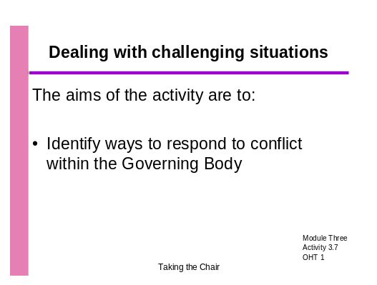
Introduce the activity using Activity 3.7: OHT 1

- Explain that participants are going to view a video depicting an extract from a badly organised meeting which prompts an emotional outburst from a Governor. They are going to think about the skills they need to respond from the perspective of a Chair or Chair of Committee

- Give out Activity 3.7 Handouts 1 and 2 and run through the key features of the approaches

Facilitator introduction (10 minutes)

- Divide participants into three groups A, B and C
- Give out Activity 3.7: Handout 3 and allocate each group an observation task during the video. Ask Group A to focus on Alison, the Chair of Finance Committee, Group B to focus on Ashok, the new governor, and Group C to look at the situation overall and think about how they respond to both Alison and Ashok in a meeting to discuss Ashok’s concerns
- The video is in two sections with questions on the screen between the two. Watch both sections straight through
- Ask the groups to focus on the questions on the handout rather than those on the screen, which were intended for new governors

Organisation of groups and viewing video scenario (15 minutes)

- Reorganise the groups by taking an A and B and a C from each group to form new groups. Talk through the second part of the task on Activity 3.7: Handout 3. Remind them about any relevant activities from Module Two relating to the needs of new governors.
Group work (15 minutes)

- Put pairs of trios together (6 participants) and ask them to exchange scripts or role play and:
  - Identify those questions and comments that are likely to have a positive result
  - Note what if, anything, could be improved
  - Estimate the likelihood of a satisfactory outcome for each example

Group work (10 minutes)

- Hold a plenary to pull out examples of good practice. Ask for examples of approaches and behaviours which worked well and think about why they worked well. Highlight key skills being used.
Facilitator led plenary (10 minutes)

The Empathetic Model for Conflict Resolution
Stage/skill | Behaviour | Outcome
Listen | - Don’t interrupt or talk over them  - Listen actively  - Maintain eye contact appropriately | Shows respect and a desire to co-operate  Gains control
Show understanding and respect | - Model the behaviour you want to see  - Apologise if you’re in the wrong  - Stay calm  - Use their names  - Paraphrase to show you have understood.  Acknowledge their feelings ‘I can see you’re angry’.  - Look as if you mean what you say –take care re body language | Shows you care
Ask supportive questions and open questions | - I can see this causes difficulty for you, would it help if….  What can we do to improve matters?  - How would you feel if…? | Ensures you have all the information you need before moving to a solution  Enables you to be assertive  Shows that you wish to co-operate  Gains control
Explain | - Take care with tone of voice  - Stick to the issue | Encourages understanding
Seek joint agreement | - Give a sense of making a choice. Invite ideas re solutions/ways forward.  - Say ‘Yes and’, rather than ‘yes but’.  Avoid value-laden statements e.g. –‘I’m being very fair with you’.  - Seek win/win outcome. | Shows co-operation, and willingness to negotiate.  Gains control
Take action | Do what you say you will do in the timescale agreed | Fulfils obligation. Inspires trust and confidence
Monitor action | Check plan is working or amend. | Fulfils obligation. Inspires trust and confidence

This is most effective if you repeat the first 3 stages until the tension reduces sufficiently to be able to move on to explain your perspective.

‘Seek first to understand, then to be understood’, Stephen Covey

Stages of negotiation

Preparing:
- Consider both points of view
- Decide on fallback position
- Consider best alternative

Creating a positive atmosphere
- Stating objectives (both parties)
- Dealing with disagreements/conflict/anger
- Finding solutions and/or acceptable compromises
- Reaching agreement

Agreeing objectives – think win-win

 | YOU WIN | YOU LOSE
I WIN | WIN/WIN  Best Outcome | WIN/LOSE  Undesirable outcome
I LOSE | LOSE/WIN  Undesirable outcome | LOSE/LOSE  Really bad news!

Skilled negotiators actively:

Seek information: they spend 20% of their time asking questions compared to 10% for average negotiators
- Test understanding, summarise: they spend twice as much time testing understanding and summarising the stages negotiations have reached.
- Signal/label behaviour: they are five times more likely to signal the type of behaviour they are about to use. E.g. “Can I ask you a question...?”, “If I may make a suggestion…?”

Skilled negotiators actively avoid:
- Personal attacks/irritating
- Value-laden terms
- Attack/defend spirals
- Counter-proposals.
- Argument dilution

From: Huthwaite Research Group

Managing challenging situations: TASK

Group A: Chair of Finance Committee
Watch the scenario and consider:
- How Alison could respond to Ashok to reduce the tension
- What comments could she make?
- What questions could she ask?

What could constitute a win-win situation for both parties?

Group B: Ashok, a new governor
Put yourselves in the position of Ashok. What would he want to see happen:
- Immediately?
- In terms of future practice?
- What could he do to contribute to achieving a satisfactory outcome?
- What could constitute a win-win situation for both parties?

Group C: Chair of Governors
Put yourselves in the position of the Chair.

What would he/she do if asked to facilitate a meeting between the two of them immediately after the outburst?

What could constitute a win-win situation?

After the video and in new groups:

- In your roles, plan what you would do and say at a meeting to address the concerns expressed by Ashok
- Think about the best way of approaching the situation and what you are trying to achieve
- The objective of the discussion between the three parties is to create a productive working relationship which benefits the work of the Governing Body

Either:

- Write rough notes or a script so that you can feed back on the key points of the discussion to another group, or
- Construct a very short role play to show what each of you would do or say in the situation

3.8 Managing an effective meeting: Checklist

Aims

To give participants an opportunity to make a self assessment of their effectiveness in managing meetings

Overall length

10 minutes

Resources

Activity 3.8: Handout 1

Key notes for Facilitators

A meetings checklist is included here:
- You may wish to develop this into an activity in preference to the role-play Activity 3.9
- You may wish to offer it as a pre- or post-session task
- You could give this out after Activity 3.9 for participants to use to reflect on their own skills as Chair but it is useful for them to have considered aspects of effective chairing before taking part in the role-play

The checklist prompts participants to consider the effectiveness of their own role in chairing and managing meetings. Participants should be encouraged to:
- Check their perceptions with a colleague or the Headteacher
- Consider what action or support is needed to improve

Managing an effective meeting: Checklist
Circle the number which most applies:
1 = Always, 2 = Often or usually, 3 = Sometimes, 4 = Never

1 | Before a meeting I make sure that I know how a formal meeting should be run | 1 | 2 | 3 | 4
2 | I make sure I am well prepared for the meeting | 1 | 2 | 3 | 4
3 | I begin the meeting at its scheduled start time | 1 | 2 | 3 | 4
4 | I make sure governors understand the minutes of the previous meeting | 1 | 2 | 3 | 4
5 | I explain the purpose of the meeting clearly to all the participants especially new governors | 1 | 2 | 3 | 4
6 | I follow the agenda for the meeting | 1 | 2 | 3 | 4
7 | I make sure that governors always speak through the Chair even if informally | 1 | 2 | 3 | 4
8 | I know what each governor’s motives and hidden agenda are | 1 | 2 | 3 | 4
9 | I make sure all governors are fully involved in the meeting | 1 | 2 | 3 | 4
10 | I allow all points of view to have a fair hearing | 1 | 2 | 3 | 4
11 | I encourage respect for the professional views of the Headteacher and staff | 1 | 2 | 3 | 4
12 | I make sure those attending don't ramble or adopt aggressive attitudes during discussions | 1 | 2 | 3 | 4
13 | I don't express my own views until the end of a discussion | 1 | 2 | 3 | 4
14 | I enable the Clerk to take accurate minutes of the meeting | 1 | 2 | 3 | 4
15 | I make sure all governors know what action to take before the next meeting | 1 | 2 | 3 | 4
16 | I make sure the date, time and place of the next meeting is known to all | 1 | 2 | 3 | 4
Total score:
What does your total score suggest?
16-41 Your meetings are effective and probably enjoyable!
42-47 You run quite effective meetings
48-54 You could run more effective meetings
55-64 You are finding this difficult and need more support
Do you need to plan any action?

Activity 3.9: Chairing meetings

Aims

- To provide experience of taking part in a meeting to observe and evaluate chairing skills
- To consider how to manage behaviours and concerns in a meeting
- To reflect on the skills required to manage conflict

Overall length

- 40 minutes

Resources

- Activity 3.9: OHTs 1-2
- Activity 3.9: Handouts 1 and 2
- Role cards – cut up

Key notes for Facilitators

- Participants will either practise being the Chair in their group or contribute to the discussion on improving chairing skills
- Emphasise, if necessary, that this activity is not role play but discussion in their usual role of governors at meetings
- There are 8 specific roles, additional participants should be given ‘Governor’ cards
- Ensure that there is an appropriate spread of roles if working in two small groups
- The issue under discussion is not of central importance, the focus of the activity is on what the Chair does and how he/she manages a meeting and reacts to typical types and situations
- If there is a local issue which you feel would make a better discussion point you will need to produce an alternative briefing sheet (How to deal with pupils taking holidays in term time might be one alternative discussion topic)

Task 1: Chairing a meeting

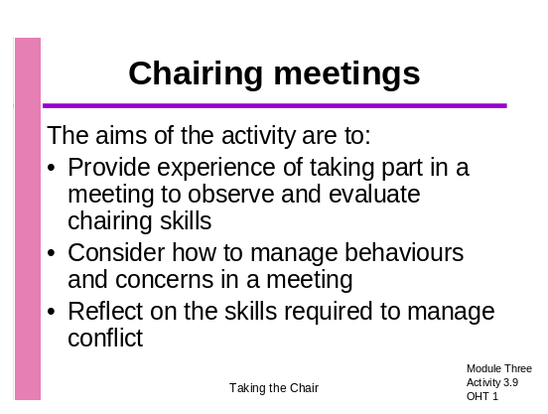Use Activity 3.9: OHT 1 to introduce the activity

- Put participants into one large group of up to 12, or two smaller groups, depending on how much space you have
- Give out the role cards and a copy of Activity 3.9: Handout 1 to all participants
- Draw everyone’s attention to the agenda item, the timing of the meeting and the time allowed for the agenda item
- Ask participants to arrange the furniture for the meeting and to decide where the Chair, Headteacher and Clerk should sit

Introduction, organisation of groups and furniture (10 minutes)

- When everyone is seated, invite the Chair to open the meeting and lead the discussion

Group discussion (15 minutes)

- Stop the discussion after 15 minutes if the Chair has not already done so

- 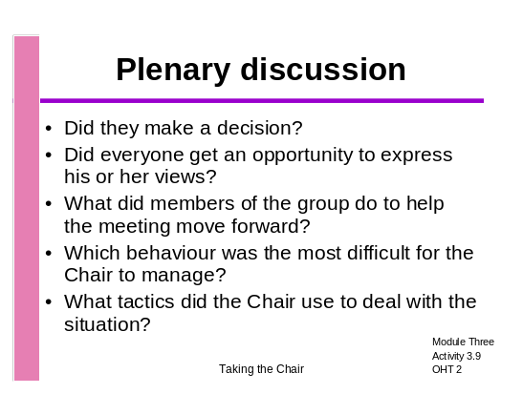Give everyone a few moments to consider the questions on Activity 3.9: OHT 2 (The value of time to reflect is that the discussion does not get controlled by the confident participants who are quick to air their views)

- Lead a discussion around the questions
- Ensure that positive feedback is given to the ‘Chair’
- Feedback on the skills you observed in action (see Skills checklist in Toolkit Introduction) with examples of how they were effective and ask for key learning points
- Give out Activity 3.9: Handout 2

Plenary discussion (15 minutes)

Chairing a Meeting: Briefing for participants

Time of meeting: The autumn term
Time allocation for this agenda item: 15 minutes

Agenda item Number 1

To discuss a proposal to ban parents from parking on or turning round in the school car park

Background to the agenda item:
- The school is in a large village in a rural area
- There is a narrow road outside the school with gates to the car park and to the pathway to the playground area
- Transport is available for pupils living the prescribed distance from the school
- The car park is adjacent to the playground with no barriers between them
- The school is part of the Healthy Schools project
- Many parents drive their children to school

Pedestrian gate
Car park
Playground
Vehicle entrance
Two-way traffic
School
Chairing a meeting

Chair | Clerk
Governor who does not like change | New Parent Governor  Single parent, lives in the village and works 20 miles away. Regularly drives child to school
Governor who likes everyone to agree | Governor who likes to get through the agenda as quickly as possible
Quiet Governor  Lives 3 miles away but drives  child to school because he does not like travelling on the school bus | Governor who goes off at a tangent
LEA Governor who made the initial suggestion | Headteacher

Managing Conflict

Conflict can be an inevitable part of decision making. Research shows that teams that do not always agree make better decisions and achieve more than teams who are always in agreement.

When people become entrenched in their views, the Chair has to manage the situation carefully so that relationships are not damaged and the group is not prevented from making a corporate decision.

When faced with conflict, we sometimes become emotionally involved and become challenging or defensive. This sort of reaction can cause long-term damage rather than resolving the situation.

Listen → Stop → Think → Stop →Speak

Strategies for resolving conflict include:

- Asking people who are upset to explain why they feel strongly so that everyone understands
- Asking for the views of those who are less emotionally involved but who will give a frank answer
- Summarising the different view points, adding any information which may clarify the situation
- Remaining emotionally uninvolved
- Ensuring that the views of all are given a good hearing by not rushing the decision making
- Being firm about the need to make a decision - if not immediately, then in the very near future
- Considering a vote to help come to a resolution
- Securing commitment to a corporate decision so that the disagreement does not continue
- Being clear about the process for revisiting the decision in the future
- Being sensitive to those who have lost their argument
- Being positive about the value of a healthy debate

Activity 3.10: Does it have to be the Chair?

Aims

- To identify areas of work often undertaken by the Chair which could be delegated to the Vice Chair or others
- To highlight the advantages which delegation would have for the:
  - Chair themselves
  - The Vice Chair or others
  - The Governing Body

Overall length

- 30 minutes

Resources

- Activity 3.10: OHTs 1 and 2
- Post-its
- Pens
- Five sheets of flip chart paper Blu-Tacked around the room

Key notes for Facilitators

- This activity is not about the Chair abdicating their responsibilities, but sharing the load
- Chairs and Vice Chairs can successfully share the load using each other’s strengths to best advantage
- This job share is also advantageous for governing bodies of schools in challenging circumstances
- Groups should also be encouraged to think of sharing responsibilities with governors other than the Vice-Chair
- Give lots of encouragement to the group to think differently or share their own experience of sharing the workload in their own Governing Body
- If necessary, remind group of the corporate nature of the Governing Body and that the powers of the Governing Body are vested in the body not individuals
- If you used Activity 1.2 in Module One, you might want to refer back to it here. This activity takes the Chair’s role further by looking at delegation.
- Remind participants to write one item only on each Post-it

Task 1: What tasks are the responsibilities of the Chair?
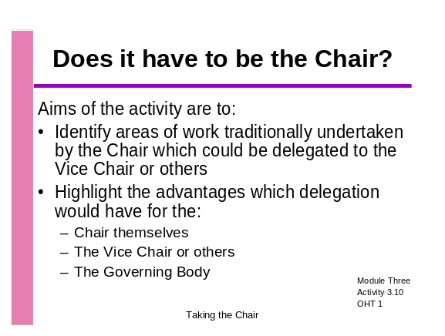
Introduce the activity using Activity 3.10: OHTs 1 and 2



- Put participants into groups of 3
- Give each group a stack of Post-its and pens
- Ask group to write on separate Post-its all the tasks they think are the responsibility of the Chair (one item per Post-it)

Introduction and group work (10 minutes)

- Now ask the participants who else on the Governing Body might be able to share some of these tasks?
- Mark up the flip charts with the roles they suggest (e.g. Vice-Chair, ex-Chair, governor with particular interests etc, and have one marked ‘Chair’.)
- Ask participants to place their Post-its on the appropriate chart if they think that person could share or be delegated a task carried out by the Chair

Sorting Post its (10 minutes)

- Lead a discussion on the tasks allocated to the Chair and others. What agreement has there been? Has the load of the Chair been lightened? Ask participants to justify choices
- What advantages do the participants see in lightening the load of the Chair?
- Comments might include:
  - Delegation provides development for others
  - Strengths and skills are used effectively
  - Broader participation strengthens involvement and motivation
  - Distributing leadership around the Governing Body reflects what happens in effective school staff teams
- Are there any disadvantages?
- Ask participants whether the activity has given them any ideas for delegating tasks

Group discussion (10 minutes)

Activity 3.11: Is this a good minute?

Aims

- To develop awareness of the need for accurate minutes which reflect the decision making process
- To explore the Chair’s role in ensuring the quality of minutes of Governing Body and committee meetings

Overall length

- 30 minutes

Resources

- Activity 3.11: OHTs 1 and 2
- Activity 3.11: Handouts 1-4

Key notes for Facilitators

- Activity 3.11: Handout 3 outlines the value and importance of accurate minutes
- Ofsted inspectors will look for evidence that the Governing Body has asked challenging questions – these need to be recorded in the minutes
- The minutes should make clear how the Governing Body has been discharging its three key roles
- This activity links to Module 2 where the role of Chairs in developing members of the Governor body was raised. It also links to activity 3.5, working with the Clerk.
- The national Training Programme for Clerks to Governing Bodies includes a minutes checklist. An additional checklist has been included which you may want to give out for participants to take away and use with their Governing Body
- The Chair also needs to make clear which items are confidential and why
- Your LEA may well give additional guidance which you would want to raise here

Task 1: Is this a good minute?
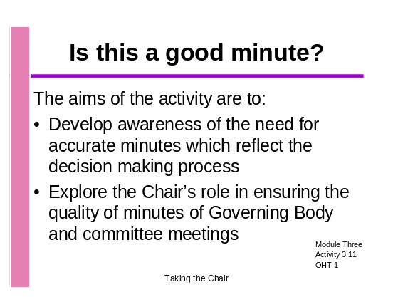
- Introduce the activity using Activity 3.11: OHT 1

Organise participants into groups of 4 or 5
- Ask participants if they are satisfied with the minutes of their meetings and if not, what the issues are
- Give out Activity 3.11: Handouts 1 and 2 and check that everyone understands the task
- As an alternative to using Handout 2 to record their actions, participants could be given a sheet of flip chart paper to draw a flow chart on a flip chart for reporting back to the larger group
Facilitator input and group work (15 minutes)

- Give each group the opportunity to justify their planned actions
- Ask each group to give one key point they would want to see recorded in the minutes
- Ask participants to describe how they work with the Clerk during meetings to ensure accurate minutes
- Distribute Activity 3.11: Handout 3

Plenary feedback and closing discussion (15 minutes)

Is this a good minute?

Task

- Read through the account of a meeting of the Governing Body and the minute written by the Clerk
- Decide in your group what action the Chair should take in the short and medium term
- Write the action on Handout 2: Chair’s action
- Decide which 5 key points should have been recorded in the minutes
- Nominate a member of your group to feedback to the others on the reasons for your actions

Background

The Governing Body of Anywhere School discussed the achievement of their KS3 pupils under the agenda item Targets and Results at their full Governing Body meeting in October.

The discussion lasted for 30 minutes

The governors looked at available data, and reminded themselves of previously agreed targets.

The governors identified various issues and the Headteacher was asked to give the governors some explanations.

Among other things, the governors raised questions about how the pupils and staff were supported. The governors were concerned and planned to ensure that more detailed information would be made available for the next meeting of the Curriculum committee. They expressed a wish to be more involved in monitoring progress and wanted to make some plans to do so.

Minute written by the Clerk

Minutes of the meeting – October 2003

Agenda Item 6: Targets and Results

Papers were distributed. Governors spent some time discussing the figures.
The Headteacher gave a verbal report. Will be a future agenda item.

Is this a good minute? Chairs action

What actions should the Chair take?

5 key points to record in the minutes

What are minutes for?

Minutes:
- Are a record of the way in which the Governing Body has discharged its responsibilities

Are a brief record of the main points of a discussion at a meeting, the decisions made and any actions decided on
- Do not have to be long, but must be a fair reflection of the variety of views
- Must be understood by someone who was not at the meeting

Every meeting of the Governing Body and of committees must be clerked
- This means that someone must be given the responsibility of taking and producing minutes of the meetings, even if it is too costly for a school to have a paid Clerk at all committee meetings

Governing Bodies can delegate decision making powers to committees
- All decision making powers of committees must be agreed by the Governing Body and laid out in the terms of reference for that committee
- Even where powers are delegated to a committee, the Governing Body is still responsible for the decisions and actions of that committee and minutes must be included in the agenda for the next full governing body meeting (except where the detail should remain confidential)

Demonstrating accountability
- The Governing Body must have access to an accurate record of all discussions and decisions so that it can demonstrate to stakeholders and to external bodies, such as Ofsted, that it:
  - Is acting as a critical friend by questioning, acknowledging success and challenging
  - Is acting strategically – demonstrated by the focus on evidence of pupil achievement and school improvement priorities
- Minutes should record the key points made by those present in a fair and balanced way
- Minutes should clearly record the corporate decisions and any action to be taken

The Chair’s role
The Chair has a role to play in ensuring that the minutes of governing body meetings serve as an accurate record. The Chair does this by:
- Listening carefully to the discussion
- Summing up the key points to aid the Clerk in recording the discussion
- Ensuring that the Governing Body has agreed a decision
- Wording that decision to aid the Clerk in recording
- Taking action if minutes are not adequate
  - Making recommendations to Clerks
  - Ensuring that Clerks have access to appropriate training

The Chair also ensures that Chairs of committees work in the same way with their Clerks or minute takers.

Governing Body Minutes Audit

Do your Governing Body minutes provide evidence of its support for school improvement?

Evidence | Comment
The agenda and discussion make clear links to priorities in the School’s Improvement Plan
There is evidence of an explicit focus on pupil achievement
The PANDA and other sources of data are used by the Governing Body to monitor and evaluate performance.
Governors are aware of the progress made by different groups of children.
Governors are aware of performance within key stages and within curriculum areas
The governing body is fully involved in formulating, promoting, monitoring and evaluating policies
Discussions about the budget are referenced to the school’s strategic priorities
Governors challenge the senior leadership team in a constructive manner
Governors acknowledge and celebrate success
Reports are presented to the Governing Body by various members of the Leadership Group
The Governing Body demonstrates a clear understanding of the school’s strengths and weaknesses.
The meeting was clearly focused, action points were agreed and recorded

Activity 3.12: Plenary Activity

Aim

- To reflect on learning
- To evaluate the session
- To prepare for the next session or module

Overall length

- 15 minutes

Resources
- Activity 3.12: OHTs 1-2

Task 1: Plenary discussion
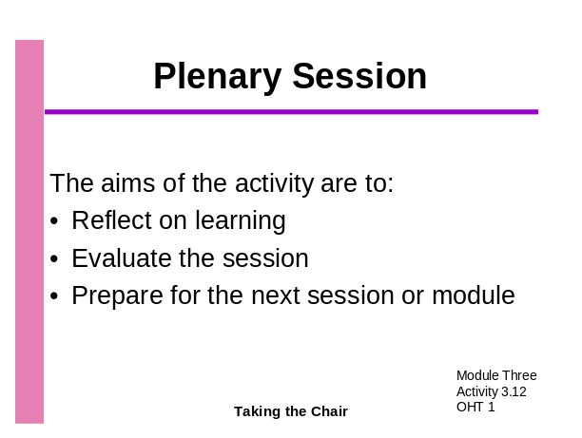
- Introduce the plenary session using Activity 2.9: OHT 1

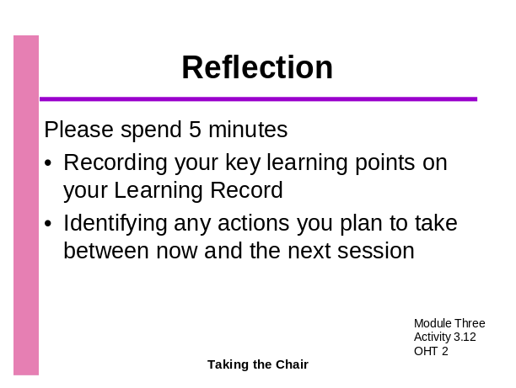
- Encourage participants to spend 5 minutes recording any actions for the future identified in this session on their Learning Record using Activity 3.12: OHT 2
- Take one point from each participant and record it on a flip chart
- Distribute any remaining related handouts
- Discuss the objectives of the next session and distribute any preparatory tasks
- Ask for any questions or comments
Plenary session (15 minutes)

Task 2: Preparation for Module Four

Activity 4.3 and Activity 4.4

If you are planning to use Activity 4.3 or 4.4, ask participants to:

- Look at a copy of the latest school prospectus and consider how the school’s values, vision and aims are communicated
- It will be helpful if they bring the school prospectus with them to the session.

Activity 4.6

If you are planning to use Activity 4.6 you will need to ask participants to:

- Obtain the most recent copy of the school improvement plan and refresh their knowledge of its contents and how the Governing Body was involved in the development of the plan
- Ask the Headteacher whether he/she is satisfied with the level of Governing Body involvement

